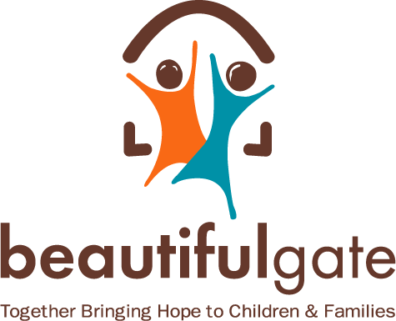

Beautiful Gate South Africa
Learner Education Support – After School Programme (High School)
Volunteer Application Form 2022

PERSONAL DETAILS:
First Name:
Surname:
Gender:
Age:
CONTACT DETAILS:
Telephone Number:
Alternative Number:
Email:
Address Line 1:
Address Line 2:
City/Town:
Postal Code:
Are you able to commit twice a week from 14:30- 16:30?
How did you hear about the Beautiful Gate Afterschool Programme?
ACADEMIC RESULTS:
Name of School:
City/Town:
Which grade are you currently in?
SUBJECT: | MARK %:
QUALIFICATIONS: (If applicable)
- Qualification:
Institution:
In progress or completed:
- Qualification:
Institution:
In progress or completed:
- Qualification:
Institution:
In progress or completed:
VOLUNTEERING EXPERIENCE: (if applicable)
Institution:
Experience:
Period:
Institution:
Experience:
Period:
PERSONAL STATEMENTS AND OPINIONS:
Write a brief Personal Statement.

Why are you interested in the Afterschool Programme?

What value will you add to the Afterschool Programme?

- REFERENCES:
Name:
Organisation:
- Contact Number or Email:
Name:
Organisation:
- Contact Number or Email:
Name:
Organisation:
Contact Number or Email:
Please attach a certified copy of your Matric Certificate and any other Post Matric Qualifications that you have and submit them with this application. | Applications close on the  31st March 2020  Only shortlisted candidates will be contacted.

